Values of Nerve Transfer in Upper Limb Nerve Injury
Mohammad- Reda Ahmad ^{(a)} ,Gamal Ibrahim Elhabbaa ^{(b)} ,Muhammad Hassan Muhammad Abdel-Aal^{(c)} , Atef Abd_Elghany Salem^{(d)} Ahmed Mohammed Kamel Tohamy^{(e)}

(a and c) Department of Plastic & Reconstructive Surgery, Zagazig University hospitals, Egypt.
(b ,d and e ) Department of General Surgery Benha University hospitals, Egypt.

Correspondence to: Ahmed Mohammed Kamel Tohamy
.
E-mail:amktsa@Gmail.com
T: 01062868901

Abstract
Background :Nerve transfer surgery involves taking nerve branches from a neighboring nerve and redirecting them to the distal end of the injured nerve⁽¹⁾. A high-level nerve injuries with extensive gap , Major bony or vascular injuries Time from injury ,prolonged beyond that acceptable for grafting , Segmental nerve injury requiring several grafts , Segmental nerve injury with no grafts available ,Scarred area of injury containing vital structures with unacceptable risk of operative injury , Partial nerve injury with a defined functional loss ,Injuries of undefined level such as radiation trauma. ⁽²⁾ . So early intervention for traumatic brachial plexus and peripheral nerve injuries is recommended to get good results with pain relief ⁽²⁾. the aim of the study is to evaluate outcomes of nerve transfer surgeries and their outcomes as a method of nerve repair the methods the patients were tested for full labs and pre operative EMG and nerve conduction tests ,MRI were done the procedures were followed for about 6months and comparing motor power and sensation score according to scale of medical research council and DASH score preoperatively and post operatively the results on 20 patients were done at zagazig university hospitals The mean age of the studied patients was 23.3 ±11.3 years. There was a male predominance (85.0%) The most frequent mode of trauma was RTA (40.0%), Regarding the level of injury, more than half had an injury at the brachial plexus (55.0%) The most frequent procedure done was Spianl accessory Nerve to Supra scapular nerve transfer (31.9%), followed by anterior interosseous nerve to the deep motor branch of the ulnar nerve transfer (26.5%), Intercostals to musculocutaneous nerve transfer (20.6%) and long head of Triceps(11.8%) ,FCR branch from Median to Musculocutaneous nerve Post-operatively, about one third (32.4%) had M5 muscle power according to Medical Research Council scale (MRC) and M4 muscle power 26.5% compared to two-thirds (61.8%) had M0 muscle power, and about one-third (38.2%) had M1 muscle according to motor power scale, The median DASH score significantly declined from 30 pre-operative to 26 post-operative (P = 0.001).
key words : neurotization , nerve transfer, brachial plexus, nerve injury
introduction
A peripheral nerve fibre may be categorized as motor fibrer, sensory fibre or autonomic (sympathetic or parasympathetic) fibre, consequently a peripheral nerve trunk represents a mixed cable of the above types of fibres.⁽³⁾
In developing countries studies revealed that nerve injuries are most common in the upper extremities in both children (78.36%) and adults (63.54%). The common causes of nerve injury in children were as follows: obstetric lesions (46.78%), iatrogenic lesions (16.95%), traffic accidents (15.7%), and sharp lacerations (12.8%), whereas the commonest cause of nerve injury in adults was due to sharp lacerations (27.57%), followed by iatrogenic lesions (25.67%), and traffic accidents (23.77%).⁽⁴⁾
Classification of nerve injury described by Seddon⁽⁵⁾ comprised neurapraxia, axonotmesis and neurotmesis. Sunderland ⁽⁶⁾ this classification system to 5 degrees of nerve injury, later on a sixth-degree injury was introduced by Mackinnon.⁽⁷⁾
The improved modern-day outcome of brachial plexus reconstruction, even with severe degrees of palsies involving root avulsions, is a result of many factors: first, the advent of microsurgical techniques, second, better understanding of the nature of brachial plexus injuries and third, the extensive research on surgical techniques ⁽²⁾

Nerve transfers do have some disadvantages. The clinical results of a nerve transfer, unlike tendon transfer, do take months to materialize. Tendon transfers allow one to see the results of the surgery within weeks⁽⁸⁾

Early exploration within 2 weeks is recommended for open injuries with nerve lacerations or transections. At this time, the nerve may be repaired primarily or with a nerve graft, Observation for 3 months is recommended after closed traction nerve injuries; many of these patients will recover spontaneously⁽⁹⁾
The rehabilitation program following motor nerve transfers must include muscle strengthening, with the emphasis on muscle balance, reeducation, cortical mapping, and normal motor patterns.⁽¹⁰⁾

aim of the study
to evaluate outcomes of nerve transfer surgeries and their outcomes as a method of nerve repair
Patients and Methods
This Interventional study has been conducted at the plastic &
Reconstructive department, faculty of medicine, Zagazig university
hospitals in the period from 12/2018 to 10/2021. twenty patients, 17 males
and 3 females, the patients included were> 3 months up to<60years , Patient with traumatic upper limb nerve palsy, Clinically manifested sensory or motor disturbance and we excluded Patients refused surgery, Patients were unfit for surgery, Patient with joint stiffness , Patient with major comorbid disease eg. Diabetis mellitus, Patients who refused to continue in this study , Patients who escaped during the follow up
Written informed consents were obtained from the patients after
approval of Ethical Committee
A full history was taken examined the involved and uninvolved extremities started by sensory examination by dermatomal mapping of the upperlimbs and detection of sensory scale according to Medical Research Council (MRC) sensory scale
Vascular examination ,chest examination and vertebral bone examination are important in detection level of injury
Motor examination of muscles of whole upper limb ordered by levels (roots, trunks ,cords peripheral nerves and detection of degree of muscle power according to Medical Research Council (MRC) motor scale (table 1)

Table 1: Medical Research Council motor grading scale. Parry , et al⁽¹¹⁾
Grade | Muscle status
0 | No contraction
1 | Flicker of contraction
2 | Active motion, gravity eliminated
3 | Active motion against gravity
4 | Active motion against resistance
5 | Normal strength
assessment of upperlimb function by Disability of the arm,shoulder and hand (DASH) ⁽¹²⁾ questionnaire which includes 30 points of daily activities and classifies it into 5 ability grades the questionnaire is interpreted as 0 is the best score, 100 is the worest
investigations
Full lab examination and viral markers according to hospital protocols, Plain X-ray on chest ad affected limb was done , EMG and nerve conduction velocity was done for the affected limb,CT and MRI myelography. Superficial U/S was done on nerves to ensure complete tear of nerve.
Operation general technique
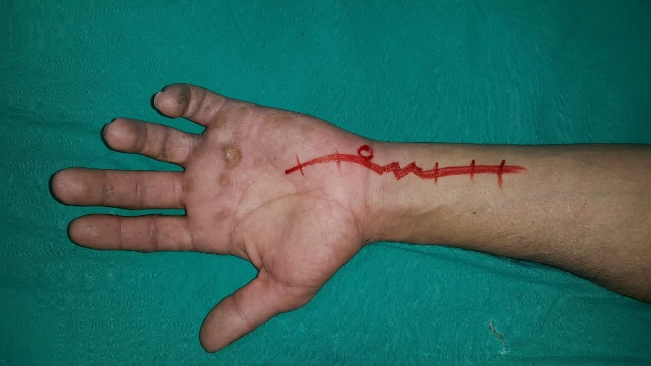
a.marking of incision expected to be done( figure 1)

Fig(1): pre operative marking of incision in case of Ulnar Nerve palsy

b.opertion is done under general anaesthia without muscle relaxants under pneumatic tourniquet and by using nerve stimulator to identify recipient and donor nerves (figure 2)
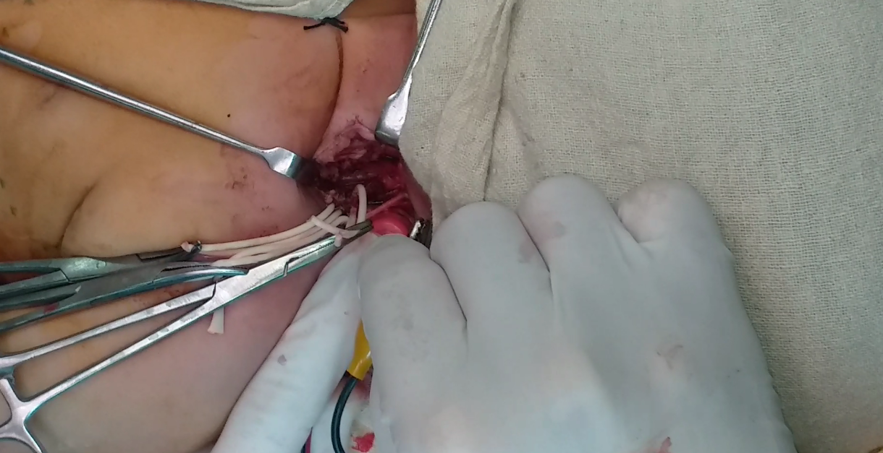
Figure(2): intraoperative pherenic nerve stimulation by nerve stimulator
c.recepient nerve is identified by nerve stimulator , dissected and transected as high as possible (figure 3)
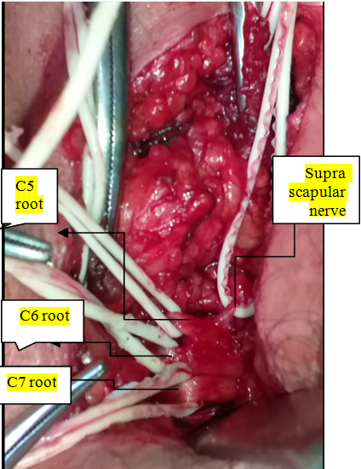

Figure (3): dissection of roots c5,c6 and c7 with supra scapular nerve.

d.donor nerve is identified by nerve stimulator, dissected and trnsected as low as possible and if fascicular transfer is planned internal neurolysis is done after identification of the appropriate nerve fascicles (figure 4)
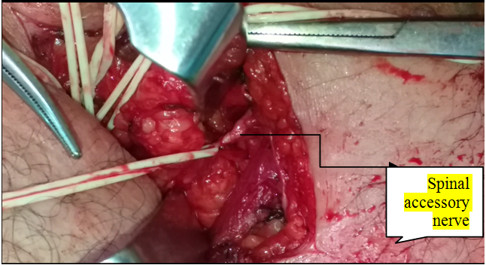

Figure(4): Dissection of spinal accessory nerve as donors for supra scapular nerve

e. suturing of nerves by microsurgical techniques by 8_0 or 9_0 nylon in atension free manner (figure 5)
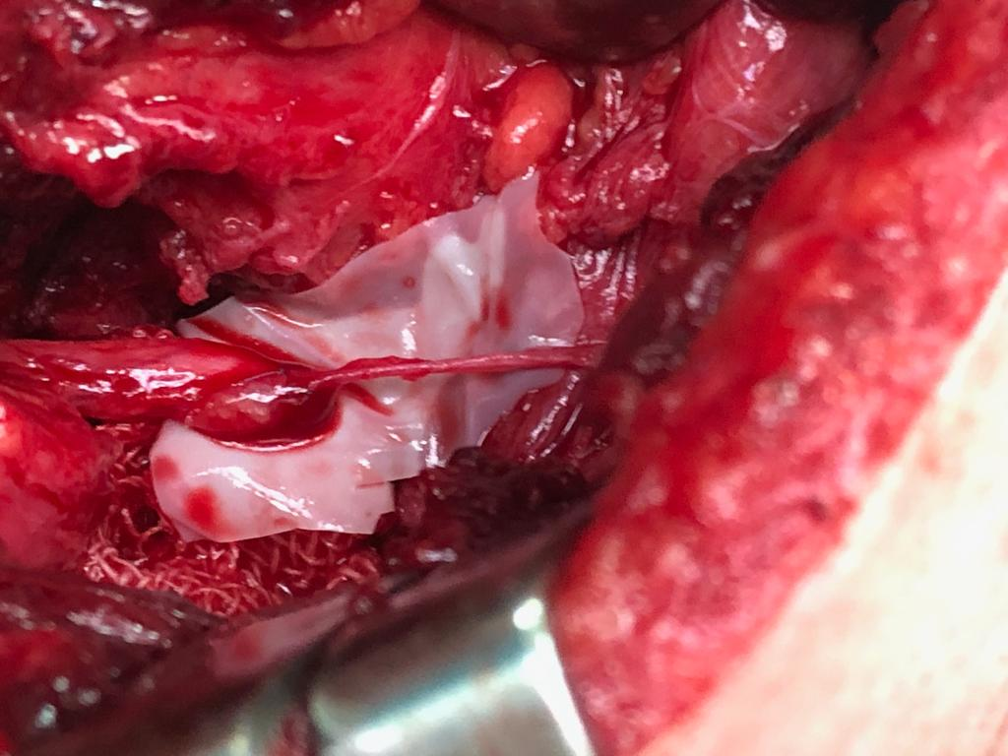
Figure(5): anastmosis of spinal accessory nerve to supra scapular nerve

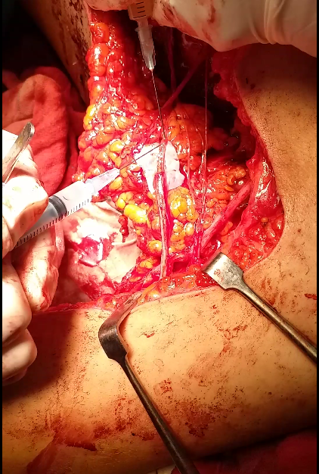
f.fibrin glue insetion on surface of anastmosis for more adherence (figure 6)

Figure(6): Fibrin glue dripping on the surface of anastmosis
post operative measures
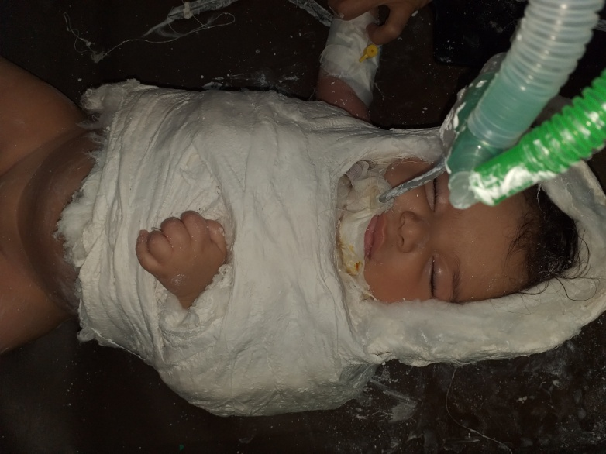
Strict immobilization either by slaps of casts or even toupe casts (figure7) for pediatrics for period of 3 weeks was done to give the nerve transfer time to gain strength enough to withstand movement and physiotherapy Physiotherapy was delayed till this period of immobilization ends.

Figure (7) : intraoperative toupe position cast for 4 month old OBPP
Once signs of motor reinnervation start to appear, physiotherapy was
directed towards active muscle excercises to improve muscle power.
also reeducation of patients to improve control of reinnervated muscles and to decrease the effect of antagonistic co-contractions.
Follow up for the patient was done at 3months, 6months & 1 year intervals with clinical examination and EMG of intrinsic muscles,motor power according to Medical Research Council (MRC) grading and calculation of (DASH) score for comparison with preoeratve data and assessing efficacy of the procedure.
Results
The mean age of the studied patients was 23.3 ±11.3 years. There was a male predominance (85.0%). The most frequent mode of trauma was RTA (40.0%), while the least frequent was gunshot (5.0%). Regarding the level of injury, more than half had an injury at the brachial plexus (55.0%), and the others at forearm; lower forearm (15.0%), middle forearm (5.0%), and upper forearm (25.0%). About two-thirds had the dominant hand affected (65.0%). The median time to surgery was 4 months and ranged from 3-12 months
and median range of follow up 6 months and ranged from 6 to 8 months (figure 8)

Figure (8) Level of injury of the studied patients

The most frequent procedure done was Anterior Interosseous Nerve to Deep motor branch of Ulnar nerve (26.5%), followed by IC to MC (20.6%), SAN to SS (anterior approach) (20.6%), IC to long head of triceps (11.8%), SAN to SS (posterior approach) (11.8%), and FCR branch from median nerve to MC (8.8%) (Table 3).

Table (3) Procedures conducted on the studied patients
 |  | n (%)
Procedure done | Ant interosseous n to deep motor branch of ulnar n | 9 (26.5)
 | FCR branch from Median nerve to MC | 3 (8.8)
 | IC to long head of triceps | 4 (11.8)
 | IC to MC | 7 (20.6)
 | SAN to SS (ant approach) | 7 (20.6)
 | SAN to SS (post approach) | 4 (11.8)
Post-operatively, a significant difference was observed in muscle power compared to pre-operative (P < 0.001). Preoperatively, about two-thirds (61.8%) had M0 muscle power, and about one-third (38.2%) had M1 muscle power. Post-operatively, about one-third had M5 muscle power (32.4%). One-quarter had M4 muscle power (26.5%). M0, M1, and M2 were 17.6%, 8.8%, and 14.7% (Figure 9).

Figure (9); Pre and post-operative muscle power in the studied patients

The median DASH score significantly declined from 30 pre-operative to 26 post-operative. Also, the range declined from 20-77 to 11-36 (P < 0.001) (Figure 10).

Figure (10) Pre and post-operative DASH score in the studied patients

Most patients (85.0%) showed compliance with physical therapy and deformity improvement (80.0%) (Table 4).

Table (4) Compliance to physical therapy and deformity improvement
 | n (%)
Compliance with physical therapy | 17 (85.0)
Deformity improvement | 16 (80.0)

Figure (11) Satisfaction of the studied patients
Statistical methods
Data management and statistical analysis were done using SPSS version 25. (IBM, Armonk, New York, United States). Quantitative data were assessed for normality using the Shapiro-Wilk test and direct data visualization methods. According to normality testing, numerical data were summarized as means and standard deviations or medians and ranges. Categorical data were summarized as numbers and percentages. Pre and post-operative muscle power were compared using sign test, while pre and post-operative DASH scores were compared using Wilcoxon signed ranks test. Correlation analyses were done using Spearman’s correlation. The post-operative DASH score was compared according to different parameters using the Mann-Whitney U test. Associations between post-operative muscle power and different parameters were assessed using Fisher’s exact test. All statistical tests were two-sided. P values less than 0.05 were considered significant
Case presentation
Preoperative
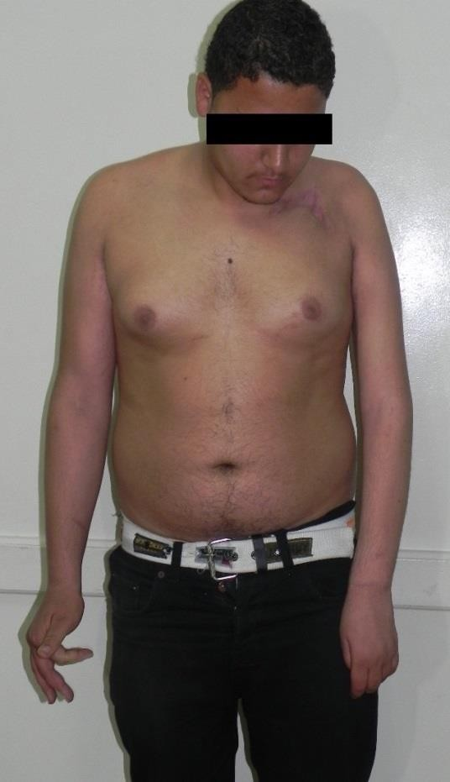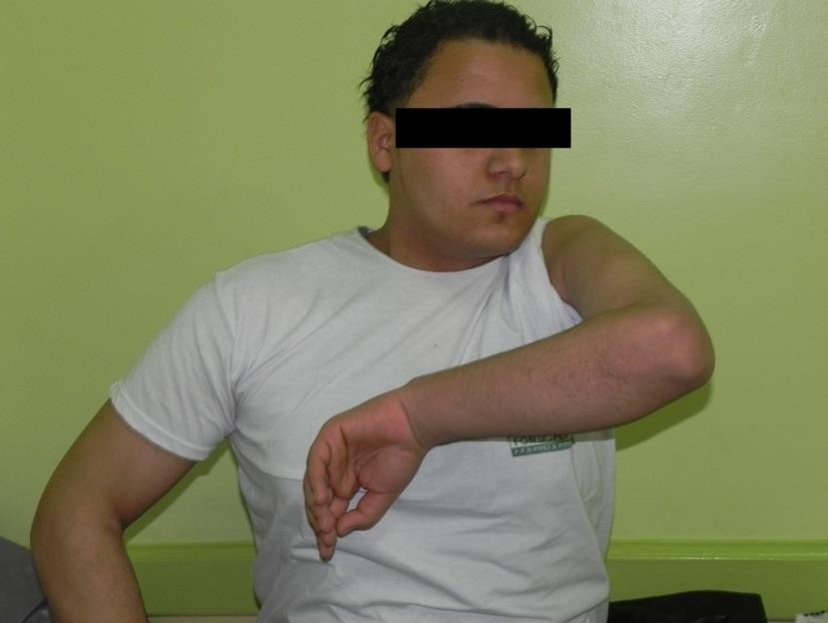
postoperative

Figure (12): Results after transfer for Spinal accessory nerve to suprascapular nerve post.approach and FCR branch of Median nerve in Parial plexus palsy in a 24 years old male
Discussion
Most of more recent studies prove the superiority of nerve transfers over the use of nerve grafts in achieving better outcomes (Chuang, 2005, Monreal, 2007a, Oberlin et al., 2009, Toussaint and Zager, 2011, Midha and Alant, 2012, Ladak et al., 2013, Liu et al., 2013, Bhandari and Deb, 2015, Wali et al., 2017). ⁽¹³⁾
This is the cause we have chosen nerve transfer as method of nerve repair in our thesis
We performed 34 nerve transfers in 20 patients, 10 for elbow flexion, 11 for shoulder abduction, 9 for intrinsic muscles of hand, 4 for elbow extension, The results were useful (M3 or more) in 25 transfers and unuseful (M2 or less) in 9 transfers. The average time before surgery was 4 months.
Several studies agreed that the outcome of functional recovery of the injured brachial plexus is highly dependable on the timing of surgical management and level and severity of the injury. It is also known that the greater the time elapsed until surgery, the less functional outcome gained due to fibrosis and muscle atrophy.(14) , (15), (16) , (17) , (2) , (19) .this why we believe that Although promising results in our follow up (average 6 months ),results could be better outcome if longer period of follow up has been done.
our study revealed significant negative correlation between time to surgery and post-operative muscle power (r = -0.542 & P = 0.013) and patient satisfaction (r = -0.554 & P = 0.021) and this agree withis other studies a study of 176 patients, Terzis and Barmpitsioti⁽²⁰⁾ ,suggested that patients with a denervation time greater than 8 months had a statistically significant restricted motor function although, in thesis by Al Sabahi ,et al⁽¹³⁾ and Martins et al ⁽²¹⁾ this finding was not evident as there was no correlation between time passed before surgery and the postoperative outcome
In our study we did 11 cases with Spinal accessory nerve transfer to Supra scapular nerve transfer , 7 cases were anterior approach and 4 cases were posterior approach , 9 casees (81%) showed improvement in motor power m3 or more according to MRC scale and this agree with results published by The (ahmad;2013) early results of spinal accessory nerve transfer to suprascapular nerve procedure regained 78.95% of functional shoulder muscle power (M5-M3), 10.50% of non functional muscle power (M2-M1) and only 10.5 % of non innervated muscle (M0) also Songcharoen et al⁽²²⁾, Chuang ⁽²³⁾, Terzis and Kostas⁽²⁴⁾ and Bertelli and Ghizoni ⁽²⁵⁾ had close results in their publications which assured values spinal accessory nerve transfer to suprascapular nerve procedure in outcome of shoulder function
however , Malessy et al reported that the reinnervation of the shoulder in patients with upper brachial plexus palsy following the suprascapular nerve neurotization is disappointingly low. ⁽²⁾
Usually this transfer is performed through the same access during exploration of the brachial plexus via the anterior approach. However, despite the satisfactory results obtained with this technique, in some cases failure may occur ⁽²⁶⁾ and this agree with results in our study which revealed better results in 4 cases with posterior approach all gave postoperative results of M5 than anterior approach post operative muscle power
In our study we did 3 nerve transfer of FCR branch of Median nerve to Musculocutaneous nerve and 7 nerve transfer of Intercostal nerves to Musculocutaneous nerve with postoperative motor power improved M3 or more in 8 cases out of 10 cases (80 %) improvement. Similar results published by ahmad⁽²⁾ In a study revealed early results of Oberlin procedure (neurotization of the musculocutaneous nerve) revealed 83.33% of elbow functional muscle power (M5-M3), 16.67% of non functional muscle power (M2-M1). In addition, the intercostal nerves transfer to musculocutaneous nerve, revealed 62.5% elbow functional muscle power (M5-M3), 25.0% of non functional muscle power (M2-M1) and only 12.5% of non innervated muscle (M0) ,also similar studies by Terzis ⁽²⁴⁾and Chuang ⁽²³⁾
in our study we did FCR branch of median nerve to Musculocutaneous nerve in partial plexus injuries with better postoperative MRC scale M5 in all cases in comparison to intercostals transfer to Musculocutaneous nerve 5 cases out of 7 improved (M3 to m4 ) according to MR
In our study we did single fascicular transfer of FCR branch of Median nerve to Musculocutaneous nerve for restoration elbow flexion other series did double fascicular transfer as One study by Martins⁽²⁾ comparing single and DFT has found no statistical difference in the functional outcome of the two approaches. On the other hand, the favorable outcome of double over single fascicular transfer was confirmed in several other studies Mackinnon et al⁽¹⁶⁾ , Ray et al⁽²⁸⁾ , Estrella and Mella⁽²⁹⁾ , Yang et al⁽³⁰⁾ , Ahmed and Aly⁽³¹⁾
in our study we did 9 nerve transferes of Anterior Interosseous nerve to deep motor branch of Ulnar nerve with success in 7 cases (77%) with motor power above M3 according to MRC scale
our study agree with Novak and Mackinnon⁽³²⁾ reported an experience of anterior interosseous nerve to the deep motor branch of the ulnar nerve. The series included eight,also other series by Battiston and Lanzetta⁽³³⁾ , Haase and Chung⁽³⁴⁾, Flores⁽³⁵⁾ Semaya⁽³⁶⁾ had similar results
In our study we did 4 cases of transfer of intercostals nerves to neurotize of Long head of triceps , postoperatively 2 cases were improved with motor power above m3 according to MRC scale
Our results are in line of , Goubier et al who transferred three ICN to the long head of triceps attained elbow extension strength graded as M4 in 7 of 11 patients with total brachial plexus palsy. ⁽³⁷⁾ also publications by Gao et al ⁽¹⁹⁾ gave close results
In contrast Zheng et al who reported poor results (M0 to M2) by transferring three ICN to the nerve for triceps in all of their seven patients. ⁽³⁸⁾
In our study we used DASH score as a measurable data to assess our results and revealed The median DASH score significantly declined from 30 pre-operative to 26 post-operative Also, the range declined from 20-77 to 11-36 (P < 0.001) the median post-operative DASH score was significantly higher in those with brachial plexus affection (32) than in those with forearm affection (13) (P < 0.001) , No significant difference was reported in the DASH score regarding dominant hand affection (P = 0.328)
Our results are close to (Abdel-Aal ,et al.,2020) whom used DASH score in their thesis and revealed the mean values of Dash score improved significantly from being 81.58 ± 10.97 preoperative to become 28.167± 5.59 postoperative (P < 0.001). this discribancy in values of questionnaire due to wide and various scopes and types of injuries and levels in our study which differentiated values of both scores from each others
In our study Most patients (85.0%) showed compliance with physical therapy and deformity improvement (80.0%) which implied positively on our results this agree with a study by ahmad
The limitations of this study are doing transfers for different diagnoses making numbers available for statistical analysis relatively low and comparison to similar studies not valuable
Summary and conclusion
In conclusion, early intervention for traumatic brachial plexus palsy is highly recommended to get better results of motor function and pain relieve. The FCR branch of Median nerve for elbow flexion restoration and posterior approach of spinal accessory to Suprascapular nerves for shoulder neurotization are preferable if possible and usually used in partial plexus palsy.
Anterior approach Spinal accessory nerve transfer to suprascapular nerve and intercostals transfer to musculucutaneous and long head of triceps are good procedures used in global plexus palsy.
Anterior interosseous nerve is a good branch to neurotize Deep motor branch of Ulnar nerve
Our recommendation:
Further studies about nerve transfer should include larger sample size and longer time of follow up period
We recommend to operate as early as possible within 4 to 6 months for maximum benefits to be achieved.

Refrences
1. Stephen H. Colbert, Susan E. Mackinnon.(2008) Nerve Transfers for Brachial Plexus Reconstruction. Hand Clin; 24: 341–361.
2. AHMAD, M. R. 2013. Early post-operative results after repair of traumatic brachial plexus palsy. Turk Neurosurg, 23, 1-9.
3.Catala, M., & Kubis, N. (2013). Gross anatomy and development of the peripheral nervous system. Handbook of clinical neurology, 115, 29-41.‏
4. Dale P, Augustine GJ, Fitzpatrick D, Hall WC, LaMantia AS, McNamara JO and White KE(2008): Nerve: anatomy. Neuroscience 4th ed; pp 11-20.
5. Seddon HJ. (2005) Three types of nerve injury. Brain 1943; 66(4): 238–288. Quoted from Green’s operative hand surgery, Philadelphia: Elsevier; 2: 1113.
6.Sunderland S. (2005) A classification of peripheral nerve injuries producing loss of function. Brain 1951; 74 (4): 491–516. Quoted from Green’s operative hand surgery, Philadelphia: Elsevier;; 2: 1113.
7.Mackinnon SE, Dellon AL. (2008) Surgery of the peripheral nerve. New York: Thieme Medical Publishers, Inc; 1988. Quoted from Stephen H. Colbert, Susan E. Mackinnon. Nerve Transfers for Brachial Plexus Reconstruction. Hand Clin; 24: 341–361.
8. Stephen H. Colbert, Susan E. Mackinnon. (2008) Nerve Transfers for Brachial Plexus Reconstruction. Hand Clin; 24: 341–361.

9.Menorca, R. M., Fussell, T. S., & Elfar, J. C. (2013): Peripheral nerve trauma: mechanisms of injury and recovery. Hand clinics, 29(3), 317–330.
10.Christine B. Novak. (2008) Rehabilitation Following Motor Nerve Transfers. Hand Clin; 24: 417–423.
11. Parry SM, Berney S, Granger CL, Dunlop DL, Murphy L, El-Ansary D, et al.( 2015): A new two-tier strength assessment approach to the diagnosis of weakness in intensive care: an observational study. Crit Care.;19
12 Kennedy CA, Beaton DE, Solway S, McConnell S, Bombardier C. The DASH outcome measure user's manual. 3rd ed. Toronto: Institute for Work & Health; 2011.

13 AL SABBAHI, Mohammad S., et al. (2019)Functional Outcomes of Primary Restoration of Elbow Flexion after Traumatic Brachial Plexus Palsy. The Egyptian Journal of Plastic and Reconstructive Surgery, , 43.1: 7-11.‏

14. Matsuyama et al., 2002
15 Tung, T. H., Weber, R. V., & Mackinnon, S. E. (2004): Nerve transfers for the upper and lower extremities. Operative Techniques in Orthopaedics, 14(3), 213- 222
16 Mackinnon SE, Novak CB, Myckatyn TM, et al. (2005) Results of reinnervation of the biceps and brachialis muscles with a double fascicular transfer for elbow flexion. J Hand Surg [Am]; 30:978–85.
17Dickson, J. K., & Biant, L. C. (2010). A good outcome following complete injury of the brachial plexus: long-term analysis of the management of two patients. The Journal of bone and joint surgery. British volume, 92(4), 540-544.‏
18 TUNG, T. H. & MACKINNON, S. E. 2010. Nerve transfers: indications, techniques, and outcomes. J Hand Surg Am, 35, 332-41.
19Gao et al., 2013
20 Terzis, J.K. and Barmpitsioti, A., 2010. Axillary nerve reconstruction in 176 posttraumatic plexopathy patients. Plastic and reconstructive surgery, 125(1), pp.233-247.
21(Martins et al., 2013).
22 SONGCHAROEN, P., WONGTRAKUL, S. & SPINNER, R. J. 2005. Brachial
plexus injuries in the adult. nerve transfers: the Siriraj Hospital experience. Hand Clin, 21, 83-9.

23 Chuang DC: Nerve transfers in adult brachial plexus injuries: my methods. Hand Clin 2005;21:71– 82.

- 24 Terzis JK, Kostas I: Suprascapular nerve reconstruction in 118 cases of adult posttraumatic plexus. Plast Reconstr Surg 117:613–629, 2006

25 Bertelli, J.A. and Ghizoni, M.F., (2010). Nerve root grafting and distal nerve transfers for C5-C6 brachial plexus injuries. The Journal of hand surgery, 35(5), pp.769-775.

26 Kim, D.H., Murovic, J.A., Tiel, R.L. and Kline, D.G., (2004). Infraclavicular brachial plexus stretch injury. Neurosurgical focus, 16(5), pp.1-6.

27 Martinez F, Pinazzo S, Jaume A, Sienra C, Ruso C (2015): Suprascapular nerve neurotization using fascicles of the spinal accessory nerve. Anterior vs. posterior approach. GERSAM Meeting. Wunzburg, Germany; 13-14.
28 RAY, W. Z., PET, M. A., YEE, A. & MACKINNON, S. E. (2011). Doublefascicular nerve transfer to the biceps and brachialis muscles after brachial plexus injury: clinical outcomes in a series of 29 cases. J Neurosurg, 114, 1520-8.
29 ESTRELLA, E. P. & MELLA, P. M. (2013). Double nerve transfer for elbow flexion in obstetric brachial plexus injury: a case report. J Plast Reconstr Aesthet Surg, 66, 423-6.

30 YANG, P. R., BRUNWORTH, L. S., GRAY, R. R. & CARDOSO, R.( 2014).Double fascicular nerve transfer for elbow flexion and extension. J Reconstr Microsurg, 30, 343-8.
31 AHMED, M. R. & ALY, A. M. (2017). Biceps Neurotization Versus Biceps and Brachialis Neurotization in Brachial Plexus Injury: Comparative Study. Egypt, J. Plast. Reconstr. Surg., 41, 111-116.

32 Novak, C. B., & Mackinnon, S. E. (2002): Distal anterior interosseous nerve transfer to the deep motor branch of the ulnar nerve for reconstruction of high ulnar nerve injuries. Journal of reconstructive microsurgery, 18(06), 459-464
33 Battiston, B., & Lanzetta, M. (1999): Reconstruction of high ulnar nerve lesions by distal double median to ulnar nerve transfer. The Journal of hand surgery, 24(6), 1185-1191.

34 Haase, S. C., & Chung, K. C. (2002): Anterior interosseous nerve transfer to the motor branch of the ulnar nerve for high ulnar nerve injuries. Annals of plastic surgery, 49(3), 285-290.
35 Flores, L. P. (2011): Distal anterior interosseous nerve transfer to the deep ulnar nerve and end-to-side suture of the superficial ulnar nerve to the third common palmar digital nerve for treatment of high ulnar nerve injuries: experience in five cases. Arquivos neuro-psiquiatria, 69(3), 519-524.

36 Semaya, A. (2015): Reconstruction of high ulnar nerve lesions by distal double neurotization using motor and sensory branches from the median nerve. The Egyptian Orthopaedic Journal, 50(2), 122-126
37 Goubier JN, Teboul F, Khalifa H. (2011) Reanimation of elbow extension with intercostal nerves transfers in total brachial plexus palsies. Microsurgery; 31 (1) 7-11
- 38 Zheng MX, Xu WD, Qiu YQ, Xu JG, Gu YD. (2010 ) Phrenic nerve transfer for elbow flexion and intercostal nerve transfer for elbow extension. J Hand Surg Am; 35 (8) 1304-1309

1. Stephen H. Colbert, Susan E. Mackinnon.(2008) Nerve Transfers for Brachial Plexus Reconstruction. Hand Clin; 24: 341–361.
2. AHMAD, M. R. 2013. Early post-operative results after repair of traumatic brachial plexus palsy. Turk Neurosurg, 23, 1-9.
3.Catala, M., & Kubis, N. (2013). Gross anatomy and development of the peripheral nervous system. Handbook of clinical neurology, 115, 29-41.‏
4. Dale P, Augustine GJ, Fitzpatrick D, Hall WC, LaMantia AS, McNamara JO and White KE(2008): Nerve: anatomy. Neuroscience 4th ed; pp 11-20.
5. Seddon HJ. (2005) Three types of nerve injury. Brain 1943; 66(4): 238–288. Quoted from Green’s operative hand surgery, Philadelphia: Elsevier; 2: 1113.
6.Sunderland S. (2005) A classification of peripheral nerve injuries producing loss of function. Brain 1951; 74 (4): 491–516. Quoted from Green’s operative hand surgery, Philadelphia: Elsevier;; 2: 1113.
7.Mackinnon SE, Dellon AL. (2008) Surgery of the peripheral nerve. New York: Thieme Medical Publishers, Inc; 1988. Quoted from Stephen H. Colbert, Susan E. Mackinnon. Nerve Transfers for Brachial Plexus Reconstruction. Hand Clin; 24: 341–361.
8. Stephen H. Colbert, Susan E. Mackinnon. (2008) Nerve Transfers for Brachial Plexus Reconstruction. Hand Clin; 24: 341–361.
9.Menorca, R. M., Fussell, T. S., & Elfar, J. C. (2013): Peripheral nerve trauma: mechanisms of injury and recovery. Hand clinics, 29(3), 317–330.
10.Christine B. Novak. (2008) Rehabilitation Following Motor Nerve Transfers. Hand Clin; 24: 417–423.
11. Parry SM, Berney S, Granger CL, Dunlop DL, Murphy L, El-Ansary D, et al.( 2015): A new two-tier strength assessment approach to the diagnosis of weakness in intensive care: an observational study. Crit Care.;19
12 Kennedy CA, Beaton DE, Solway S, McConnell S, Bombardier C (2011). The DASH outcome measure user's manual. 3rd ed. Toronto: Institute for Work & Health;
13 AL SABBAHI, Mohammad S., et al. (2019)Functional Outcomes of Primary Restoration of Elbow Flexion after Traumatic Brachial Plexus Palsy. The Egyptian Journal of Plastic and Reconstructive Surgery, , 43.1: 7-11.‏
14. Matsuyama et al., 2002
15 Tung, T. H., Weber, R. V., & Mackinnon, S. E. (2004): Nerve transfers for the upper and lower extremities. Operative Techniques in Orthopaedics, 14(3), 213- 222
16 Mackinnon SE, Novak CB, Myckatyn TM, et al. (2005) Results of reinnervation of the biceps and brachialis muscles with a double fascicular transfer for elbow flexion. J Hand Surg [Am]; 30:978–85.
17Dickson, J. K., & Biant, L. C. (2010). A good outcome following complete injury of the brachial plexus: long-term analysis of the management of two patients. The Journal of bone and joint surgery. British volume, 92(4), 540-544.‏
18 TUNG, T. H. & MACKINNON, S. E. 2010. Nerve transfers: indications, techniques, and outcomes. J Hand Surg Am, 35, 332-41.
19 Terzis, J.K. and Barmpitsioti, A., 2010. Axillary nerve reconstruction in 176 posttraumatic plexopathy patients. Plastic and reconstructive surgery, 125(1), pp.233-247.
20 Martins , McConnell S, Bombardier C . Nerve transfer to deltoid muscle using the nerve to the long head of the triceps, part II: a report of 7 cases. J Hand Surg [Am] 2003; 28 (4): 633–638.

21 SONGCHAROEN, P., WONGTRAKUL, S. & SPINNER, R. J. 2005. Brachial plexus injuries in the adult. nerve transfers: the Siriraj Hospital experience. Hand Clin, 21, 83-9.
22 Chuang DC( 2005): Nerve transfers in adult brachial plexus injuries: my methods. Hand Clin;21:71– 82.
23 Terzis JK, Kostas I (2006): Suprascapular nerve reconstruction in 118 cases of adult posttraumatic plexus. Plast Reconstr Surg 117:613–629,
24 Bertelli, J.A. and Ghizoni, M.F., (2010). Nerve root grafting and distal nerve transfers for C5-C6 brachial plexus injuries. The Journal of hand surgery, 35(5), pp.769-775.
25 Kim, D.H., Murovic, J.A., Tiel, R.L. and Kline, D.G., (2004). Infraclavicular brachial plexus stretch injury. Neurosurgical focus, 16(5), pp.1-6.
26 Martins F, Pinazzo S, Jaume A, Sienra C, Ruso C (2015): Suprascapular nerve neurotization using fascicles of the spinal accessory nerve. Anterior vs. posterior approach. GERSAM Meeting. Wunzburg, Germany; 13-14.
27 RAY, W. Z., PET, M. A., YEE, A. & MACKINNON, S. E. (2011). Doublefascicular nerve transfer to the biceps and brachialis muscles after brachial plexus injury: clinical outcomes in a series of 29 cases. J Neurosurg, 114, 1520-8.
28 ESTRELLA, E. P. & MELLA, P. M. (2013). Double nerve transfer for elbow flexion in obstetric brachial plexus injury: a case report. J Plast Reconstr Aesthet Surg, 66, 423-6.
29 YANG, P. R., BRUNWORTH, L. S., GRAY, R. R. & CARDOSO, R.( 2014).Double fascicular nerve transfer for elbow flexion and extension. J Reconstr Microsurg, 30, 343-8.
30 AHMED, M. R. & ALY, A. M. (2017). Biceps Neurotization Versus Biceps and Brachialis Neurotization in Brachial Plexus Injury: Comparative Study. Egypt, J. Plast. Reconstr. Surg., 41, 111-116.
31 Novak, C. B., & Mackinnon, S. E. (2002): Distal anterior interosseous nerve transfer to the deep motor branch of the ulnar nerve for reconstruction of high ulnar nerve injuries. Journal of reconstructive microsurgery, 18(06), 459-464
32 Battiston, B., & Lanzetta, M. (1999): Reconstruction of high ulnar nerve lesions by distal double median to ulnar nerve transfer. The Journal of hand surgery, 24(6), 1185-1191.
33 Haase, S. C., & Chung, K. C. (2002): Anterior interosseous nerve transfer to the motor branch of the ulnar nerve for high ulnar nerve injuries. Annals of plastic surgery, 49(3), 285-290.
34 Flores, L. P. (2011): Distal anterior interosseous nerve transfer to the deep ulnar nerve and end-to-side suture of the superficial ulnar nerve to the third common palmar digital nerve for treatment of high ulnar nerve injuries experience in five cases. Arquivos neuro-psiquiatria, 69(3), 519-524.
35 Semaya, A. (2015): Reconstruction of high ulnar nerve lesions by distal double neurotization using motor and sensory branches from the median nerve. The Egyptian Orthopaedic Journal, 50(2), 122-126
36 Goubier JN, Teboul F, Khalifa H. (2011) Reanimation of elbow extension with intercostal nerves transfers in total brachial plexus palsies. Microsurgery; 31 (1) 7-11
37 Zheng MX, Xu WD, Qiu YQ, Xu JG, Gu YD. (2010 ) Phrenic nerve transfer for elbow flexion and intercostal nerve transfer for elbow extension. J Hand Surg Am; 35 (8) 1304-1309
38 Abdel-Aal, M. H. M., Ahmad, M. R., Ashour, H. R. G., & Hemid, A. M. D. (2020). Posterior Approach to Neurotize Suprascapular Nerve by Spinal Accessory Nerve. The Egyptian Journal of Hospital Medicine, 81(4), 1804-1809.‏

